# 实验4：Fragment

## 一、实验目的:

* 掌握Fragment的使用，体会如何更加合理地利用大屏幕平板电脑的空间。
* 掌握Fragment的生命周期。

## 二、实验要求:

* 实现上述的基本功能要求。在此基础上，可以进一步优化界面，也可以进一步添加其他功能。
* 实验报告提交内容：1）结合系统界面（截图）介绍APP功能；2）核心实现代码（Java或Kotlin代码）和布局文件等。

## 三，实验内容：

Step1: Create new Project

Step2: Working with the Activity_main.xml

<**LinearLayout xmlns:android="http://schemas.android.com/apk/res/android"**  
 **xmlns:tools="http://schemas.android.com/tools"**  
 **android:layout_width="match_parent"**  
 **android:layout_height="match_parent"**  
 **android:orientation="vertical"**  
 **android:paddingBottom="@dimen/activity_vertical_margin"**  
 **android:paddingLeft="@dimen/activity_horizontal_margin"**  
 **android:paddingRight="@dimen/activity_horizontal_margin"**  
 **android:paddingTop="@dimen/activity_vertical_margin"**  
 **tools:context=".MainActivity"**>  
 *<!-- display two Button's and a FrameLayout to replace the Fragment's -->*  
<**Button**  
 **android:id="@+id/firstFragment"**  
 **android:layout_width="match_parent"**  
 **android:layout_height="wrap_content"**  
 **android:background="@color/button_background_color"**  
 **android:text="First Fragment"**  
 **android:textColor="@color/white"**  
 **android:textSize="20sp"** />  
  
 <**Button**  
 **android:id="@+id/secondFragment"**  
 **android:layout_width="match_parent"**  
 **android:layout_height="wrap_content"**  
 **android:layout_marginTop="10dp"**  
 **android:background="@color/button_background_color"**  
 **android:text="Second Fragment"**  
 **android:textColor="@color/white"**  
 **android:textSize="20sp"** />  
  
 <**FrameLayout**  
 **android:id="@+id/frameLayout"**  
 **android:layout_width="match_parent"**  
 **android:layout_height="match_parent"**  
 **android:layout_marginTop="10dp"** />  
</**LinearLayout**>

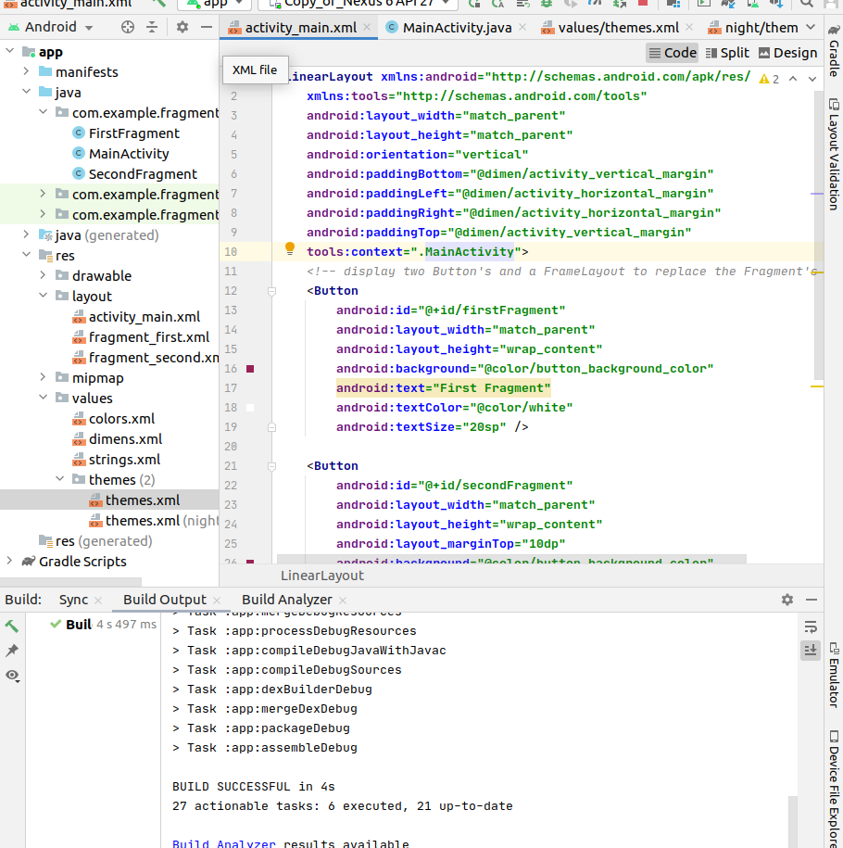.

step3: Working with the MainActivity

In this step we open MainActivity and add the code for initiate the Button’s. After that we perform setOnClickListener event on both Button’s. On the click of First Button we replace the First Fragment and on click of Second Button we replace the Second Fragment with the layout(FrameLayout). For replacing a Fragment with FrameLayout firstly we create a Fragment Manager and then begin the transaction using Fragment Transaction and finally replace the Fragment with the layout i.e FrameLayout.

Code:

**package** com.example.fragmentapp;  
  
**import** androidx.appcompat.app.AppCompatActivity;  
**import** androidx.fragment.app.Fragment;  
**import** androidx.fragment.app.FragmentManager;  
**import** androidx.fragment.app.FragmentTransaction;  
  
**import** android.os.Bundle;  
**import** android.view.MenuItem;  
**import** android.view.View;  
**import** android.widget.Button;  
  
**public class** MainActivity **extends** AppCompatActivity {  
 Button **firstFragment**, **secondFragment**;  
  
 @Override  
 **protected void** onCreate(Bundle savedInstanceState) {  
 **super**.onCreate(savedInstanceState);  
 setContentView(R.layout.***activity_main***);  
  
  
 *// get the reference of Button's*  
**firstFragment** = (Button) findViewById(R.id.***firstFragment***);  
 **secondFragment** = (Button) findViewById(R.id.***secondFragment***);  
  
 *// perform setOnClickListener event on First Button*  
**firstFragment**.setOnClickListener(**new** View.OnClickListener() {  
 @Override  
 **public void** onClick(View v) {  
 *// load First Fragment*  
loadFragment(**new** FirstFragment());  
 }  
 });  
  
 *// perform setOnClickListener event on Second Button*  
**secondFragment**.setOnClickListener(**new** View.OnClickListener() {  
 @Override  
 **public void** onClick(View v) {  
 *// load Second Fragment*  
loadFragment(**new** SecondFragment());  
 }  
 });  
  
 }  
  
 **private void** loadFragment(Fragment fragment) {  
 *// create a FragmentManager*  
FragmentManager fm = getSupportFragmentManager();  
 *// create a FragmentTransaction to begin the transaction and replace the Fragment*  
FragmentTransaction fragmentTransaction = fm.beginTransaction();  
 *// replace the FrameLayout with new Fragment*  
fragmentTransaction.replace(R.id.***frameLayout***, fragment);  
 fragmentTransaction.commit(); *// save the changes*  
}  
}

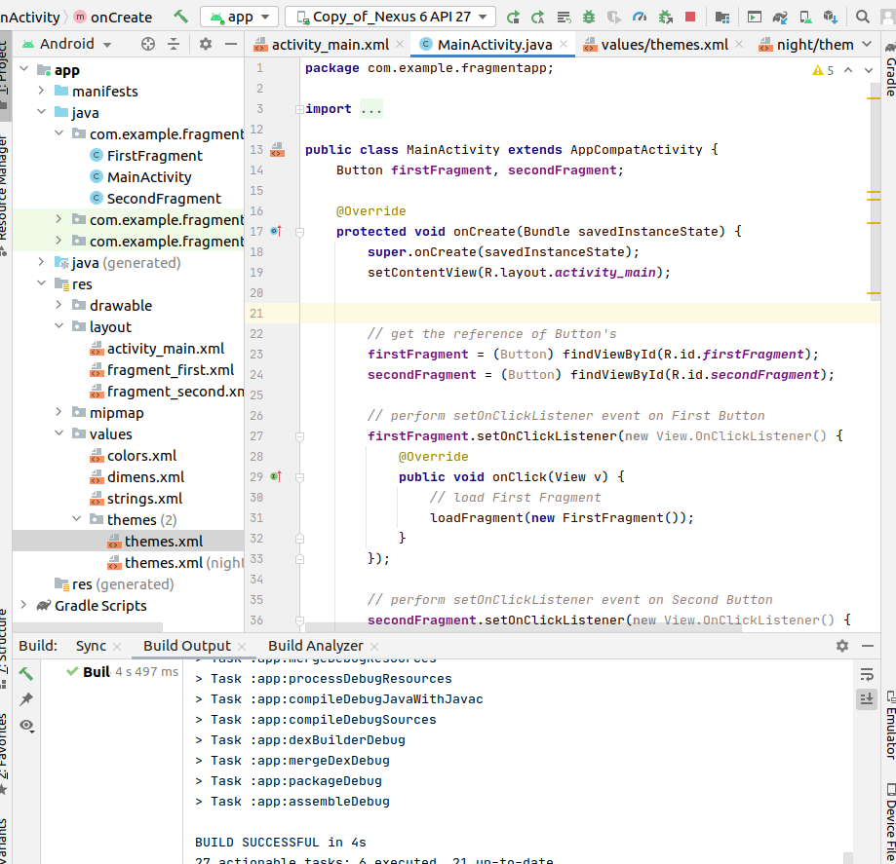.

Step4:

now we need two fragments and 2 xml layout.

FirstFragment.class

Code:

**package** com.example.fragmentapp;  
  
**import** android.os.Bundle;  
**import** android.view.LayoutInflater;  
**import** android.view.View;  
**import** android.view.ViewGroup;  
**import** android.widget.Button;  
**import** android.widget.Toast;  
  
**import** androidx.fragment.app.Fragment;  
  
**public class** FirstFragment **extends** Fragment {  
  
 View **view**;  
 Button **firstButton**;  
  
 @Override  
 **public** View onCreateView(LayoutInflater inflater, ViewGroup container,  
 Bundle savedInstanceState) {  
 *// Inflate the layout for this fragment*  
**view** = inflater.inflate(R.layout.***fragment_first***, container, **false**);  
 *// get the reference of Button*  
**firstButton** = (Button) **view**.findViewById(R.id.***firstButton***);  
 *// perform setOnClickListener on first Button*  
**firstButton**.setOnClickListener(**new** View.OnClickListener() {  
 @Override  
 **public void** onClick(View v) {  
 *// display a message by using a Toast*  
Toast.*makeText*(getActivity(), **"First Fragment"**, Toast.***LENGTH_LONG***).show();  
 }  
 });  
 **return view**;  
 }  
}

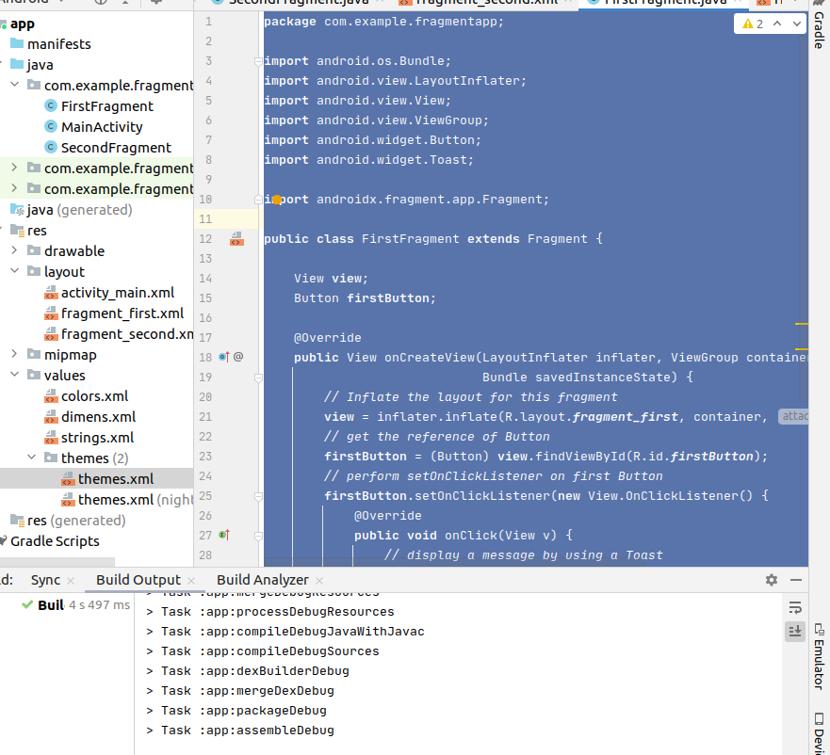.

SecondFragment.class

Code:

**package** com.example.fragmentapp;  
  
**import** android.os.Bundle;  
**import** android.view.LayoutInflater;  
**import** android.view.View;  
**import** android.view.ViewGroup;  
**import** android.widget.Button;  
**import** android.widget.Toast;  
  
**import** androidx.fragment.app.Fragment;  
  
**public class** SecondFragment **extends** Fragment {  
  
 View **view**;  
 Button **secondButton**;  
  
 @Override  
 **public** View onCreateView(LayoutInflater inflater, ViewGroup container,  
 Bundle savedInstanceState) {  
 *// Inflate the layout for this fragment*  
**view** = inflater.inflate(R.layout.***fragment_second***, container, **false**);  
 *// get the reference of Button*  
**secondButton** = (Button) **view**.findViewById(R.id.***secondButton***);  
 *// perform setOnClickListener on second Button*  
**secondButton**.setOnClickListener(**new** View.OnClickListener() {  
 @Override  
 **public void** onClick(View v) {  
 *// display a message by using a Toast*  
Toast.*makeText*(getActivity(), **"Second Fragment"**, Toast.***LENGTH_LONG***).show();  
 }  
 });  
 **return view**;  
 }  
  
}

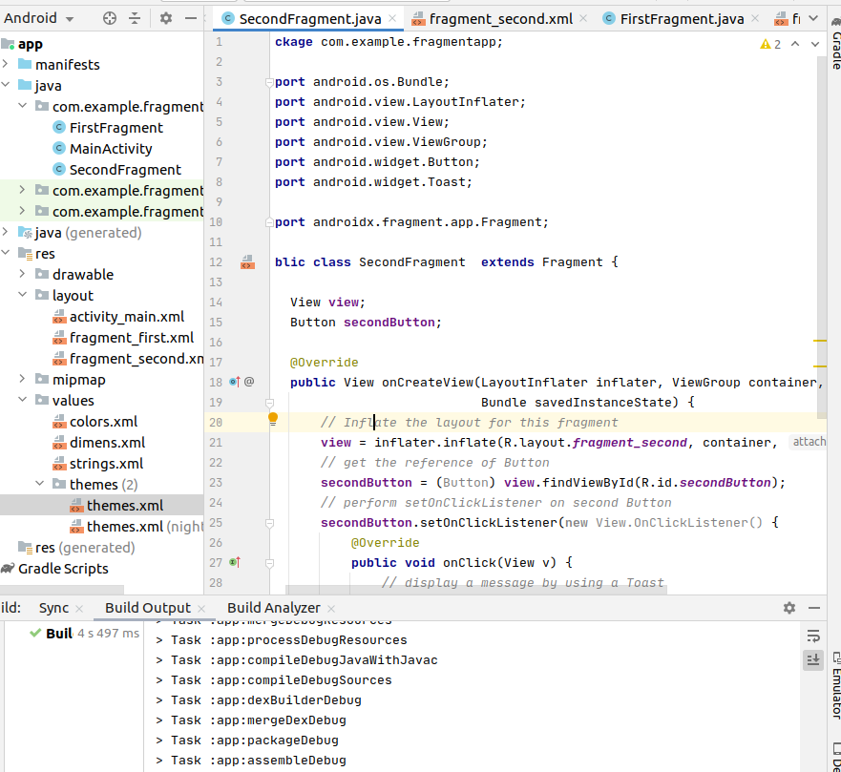.

Step5: creating 2 xml layouts

fragment_first.xml

<**RelativeLayout xmlns:android="http://schemas.android.com/apk/res/android"**  
 **xmlns:tools="http://schemas.android.com/tools"**  
 **android:layout_width="match_parent"**  
 **android:layout_height="match_parent"**  
 **tools:context="com.example.fragmentapp.FirstFragment"**>  
  
 *<!--TextView and Button displayed in First Fragment -->*  
<**TextView**  
 **android:layout_width="wrap_content"**  
 **android:layout_height="wrap_content"**  
 **android:layout_centerHorizontal="true"**  
 **android:layout_marginTop="100dp"**  
 **android:text="This is First Fragment"**  
 **android:textColor="@color/black"**  
 **android:textSize="25sp"** />  
  
 <**Button**  
 **android:id="@+id/firstButton"**  
 **android:layout_width="fill_parent"**  
 **android:layout_height="wrap_content"**  
 **android:layout_centerInParent="true"**  
 **android:layout_marginLeft="20dp"**  
 **android:layout_marginRight="20dp"**  
 **android:background="@color/green"**  
 **android:text="First Fragment"**  
 **android:textColor="@color/white"**  
 **android:textSize="20sp"**  
 **android:textStyle="bold"** />  
</**RelativeLayout**>

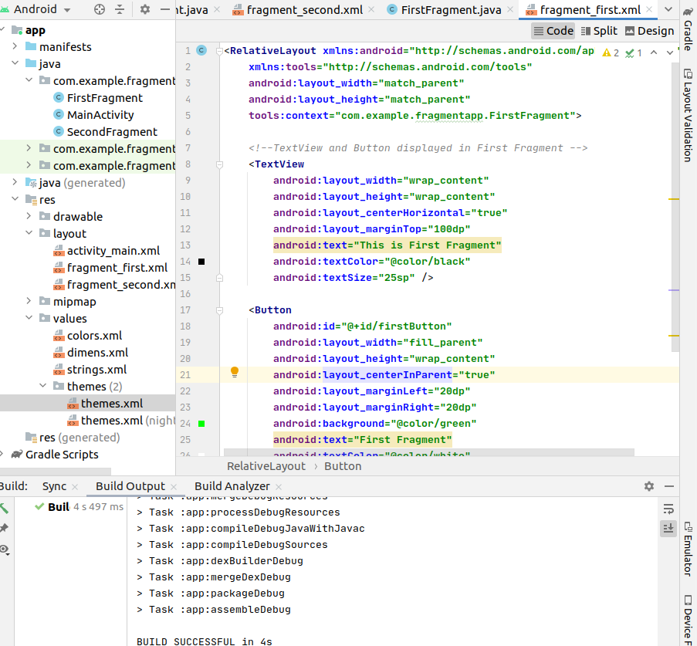.

fragment_second.xml

<**RelativeLayout xmlns:android="http://schemas.android.com/apk/res/android"**  
 **xmlns:tools="http://schemas.android.com/tools"**  
 **android:layout_width="match_parent"**  
 **android:layout_height="match_parent"**  
 **tools:context="com.example.fragmentapp.SecondFragment"**>  
  
 *<!--TextView and Button displayed in Second Fragment -->*  
<**TextView**  
 **android:layout_width="wrap_content"**  
 **android:layout_height="wrap_content"**  
 **android:layout_centerHorizontal="true"**  
 **android:layout_marginTop="100dp"**  
 **android:text="This is Second Fragment"**  
 **android:textColor="@color/black"**  
 **android:textSize="25sp"** />  
  
 <**Button**  
 **android:id="@+id/secondButton"**  
 **android:layout_width="fill_parent"**  
 **android:layout_height="wrap_content"**  
 **android:layout_centerInParent="true"**  
 **android:layout_marginLeft="20dp"**  
 **android:layout_marginRight="20dp"**  
 **android:background="@color/green"**  
 **android:text="Second Fragment"**  
 **android:textColor="@color/white"**  
 **android:textSize="20sp"**  
 **android:textStyle="bold"** />  
  
</**RelativeLayout**>

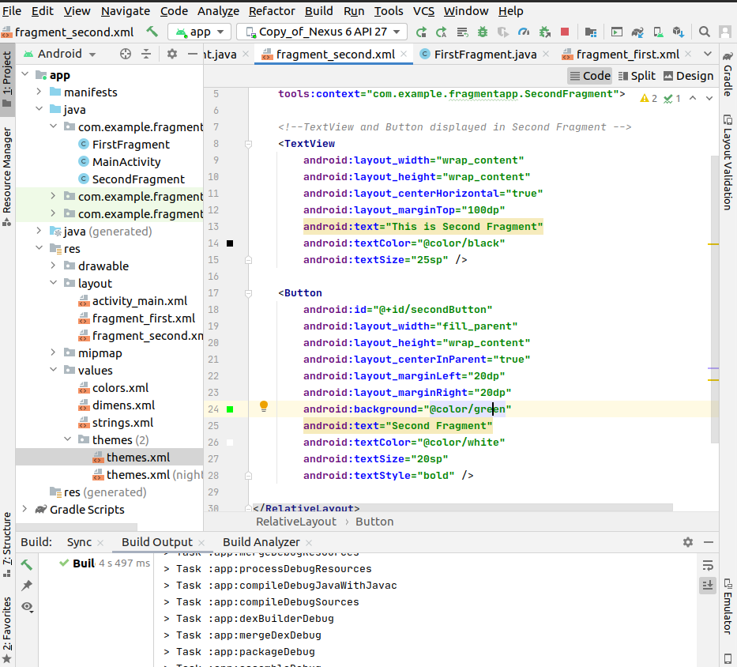.

step6: Working with the Colors.xml

*<?***xml version="1.0" encoding="utf-8"***?>*  
<**resources**>  
 *<!-- color's used in our project -->*  
<**color name="black"**>#000</**color**>  
 <**color name="green"**>#0f0</**color**>  
 <**color name="white"**>#fff</**color**>  
 <**color name="button_background_color"**>#925</**color**>  
</**resources**>

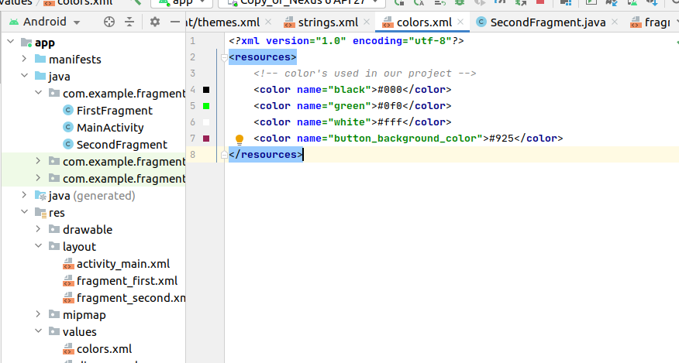.

Working Directories:

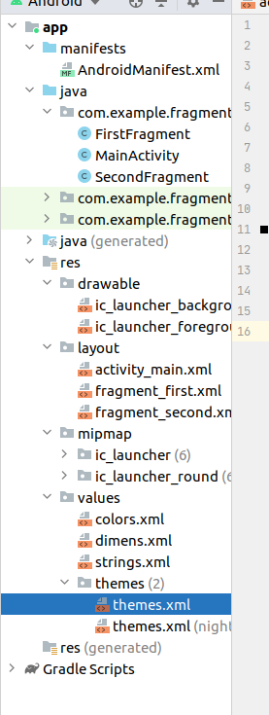

## 四、实验结果:





